My favourite topics are Euler/Hamilton paths, Euler’s formula for regions, graph planarity, and graph colouring Kuratowski’s theorem.
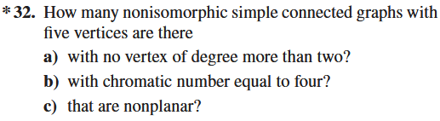
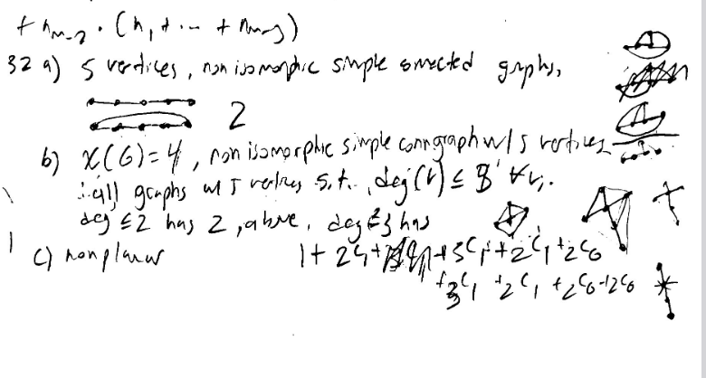
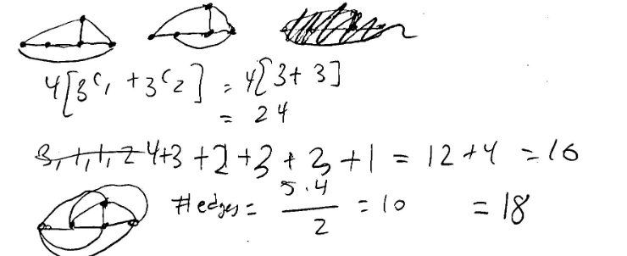
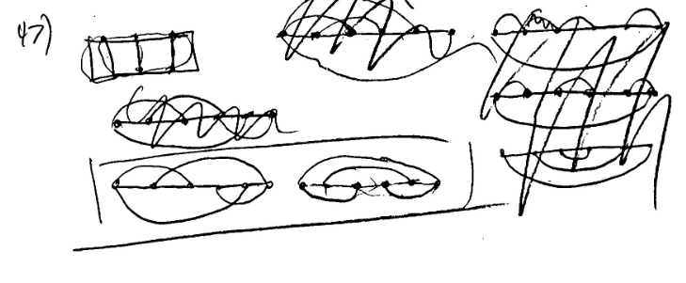

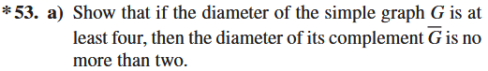
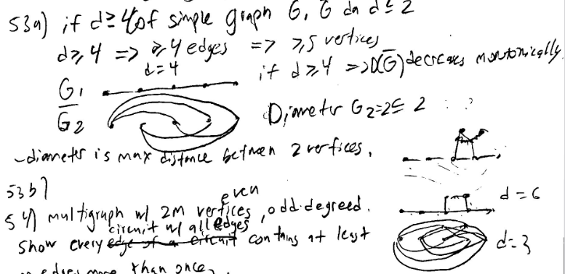
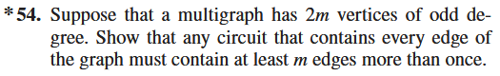
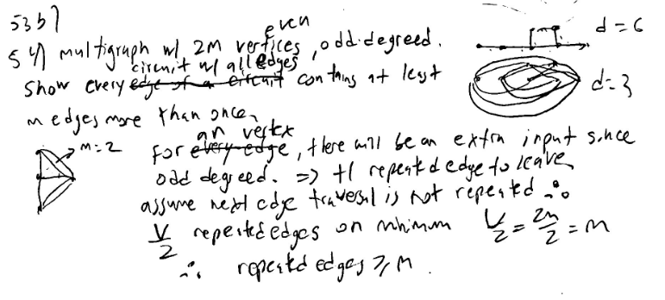
When assuming that the next node’s edge traversal is not repeated, it means that the next node’s edge is the i-th edge visited adjacent to the next node, where i is odd.
even degreed nodes to consider.
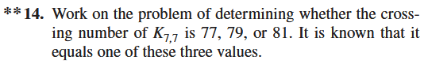
Computer problem.

A graph is a forest iff its flow semi group is aperiodic and a tree if its flow semi group is aperiodic and it contains a constant map.
